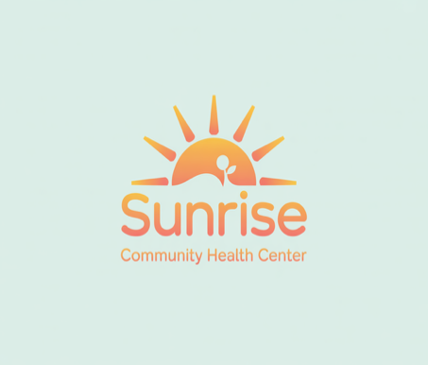

Sunrise Community Health Center
Health Center Rotational Intern

Internship Overview:
Sunrise Community Health Center is a nonprofit clinic dedicated to providing accessible, high-quality medical care to patients of all ages. Our mission is to promote wellness and preventive care while ensuring that every member of our community has access to essential health services.
This rotational internship will provide students with hands-on exposure to multiple areas of a health center, including patient intake, administrative operations, health education, and clinical support. Interns will shadow professionals, assist with daily tasks, and contribute to projects that directly support patient care.

Internship Learning Goals:
- Understand the roles and functions of various departments within a health center.
- Demonstrate professional communication skills when interacting with patients and staff.
- Learn and apply basic administrative processes, such as appointment scheduling and medical record organization.
- Gain familiarity with preventive health education practices and community outreach strategies.

What the Intern Will Do:
- Shadow medical assistants, nurses, and administrative staff.
- Assist at the front desk with patient check-in and appointment scheduling.
- Observe patient intake and learn about confidentiality and HIPAA compliance.
- Support health education programs by helping prepare outreach materials.
- Participate in staff meetings and contribute observations or ideas.

Skills and Knowledge the Intern Will Gain:
- Professional communication and customer service.
- Understanding of HIPAA and patient privacy.
- Time management in a busy healthcare environment.
- Basic health education and outreach strategies.

Preferred Skills or Interests:
- Interest in healthcare, wellness, or community service.
- Friendly, empathetic demeanor.
- Basic computer skills (Google Docs, spreadsheets).

Career Interest Categories
- Social
- Investigative

Internship Schedule:
- Start Date: January 12, 2026
- End Date: April 30, 2026
- Hours: 4-10 hours/week, early mornings preferred.

Internship Compensation:
- $20/hour.

Intern Supervision & Support:
- Direct Supervisor: Maria Lopez, Clinical Operations Manager.

Location & Work Environment:
- In-person at Sunrise Community Health Center, 123 Main Street, Santa Rosa, CA.
- Closed-toe shoes required; business casual attire.

