Lesson 2: Electrical Engineering Materials
Overview

California Content Standard(s) Addressed:
- NGSS ETS1.A: Defining and Delimiting Engineering Problems
- Crosscutting Concepts: Energy and Matter
- Science and Engineering Practices: Developing and Using Models, Analyzing and Interpreting Data, Constructing Explanations and Designing Solutions, Obtaining, Evaluating, and Communicating Information
- CCSS.MATH.CONTENT.8.F.A.1: Understand that a function models a relationship between quantities. Graph and analyze how current capacity changes with wire gauge.
- CCSS.MATH.CONTENT.8.EE.C.7: Solve equations involving I=V/R to calculate current when given voltage and resistance.
- CCSS.MATH.CONTENT.8.SP.A.1: Create scatter plots to analyze bivariate data, such as wire thickness and temperature changes.
Essential Question(s):
How do Electrical Engineers choose their materials?
Objective:
Students will explore how wires handle electrical current and understand how different factors like wire thickness, insulation, and temperature can impact a wire's capacity to safely carry electricity.
Teacher Background Information + Common Misconceptions:
- Common Misconception: Students often think a higher gauge number means a thicker wire.
- Clarification Needed: Teacher must emphasize that wire gauge is inverse → lower number = thicker wire.
  - Understanding Wire Gauges
- Teachers should be familiar with how wire thickness, insulation, and heat dissipation are tied to ampacity.
- Ampacity is the maximum amount of current (measured in amps) that a wire can carry without overheating or causing damage. If a wire carries too much current, it heats up and can melt insulation, damage components, or even cause a fire.
- Thicker wires (lower gauge numbers) can carry more current. Thinner wires (higher gauge numbers) have higher resistance, which creates more heat when current flows.
- Insulation is the protective outer layer on a wire that keeps electricity from leaking out or shocking you.
- Heat dissipation is how well a wire can release the heat it builds up as current flows. Ampacity assumes the wire can cool itself efficiently.
- Common Misconception: Students may think heat causes current to increase.
- Clarification Needed: The wire heats up because of resistance to current flow, especially in thinner wires.
- Review Ohm’s Law from Lesson 1.
- All About Circuits - Ohm's Law
- If minimal experience with a multimeter, practice using the multimeter prior to leading this lesson.
- Students will be graphing two types of data:
  - Current vs. Wire Gauge
  - Temperature vs. Time
  - Be prepared to model both types of graphs, review axes selection, and talk through interpreting data (trends, anomalies, etc.).
- Common Misconception: Students may not understand that relays are electrically operated switches and that fuses are safety components. (needed more for lesson 3)
- Clarification Needed: Use real-life analogies to explain.
  - Imagine you have a light switch across the room, but instead of walking over to flip it, you use a remote control. → The relay acts like that remote; it lets a small current control a larger current in a different part of the circuit.
  - Pressing a small “Start” button sends a signal to start the powerful engine. → The button is not directly turning the engine; it sends a signal to a relay, which connects the battery to the starter motor.

Materials
- At least three different wire gauges (e.g., 18-gauge, 20-gauge, and 22-gauge wires)
  - Pre-label gauge types and possibly color-code them
- Power supply (low-voltage battery pack or a DC power supply)
- Multimeter
- Resistors (to limit current and protect the wires)
- Lightbulbs
- Digital thermometer with a probe or infrared thermometer
- Wire strippers
- Alligator clip leads (for easy connections)
Student “I can” statements:
- I can build a simple circuit and measure current using a multimeter.
- I can explain how wire thickness affects the flow of electricity and heat.
- I can collect and graph data to show how current and temperature change with wire gauge.
- I can use Ohm’s Law (I = V/R) to solve real-world electrical problems.
- I can explain why choosing the right wire is important for safety and efficiency in electrical engineering.
- I can ask questions and identify areas I want to explore further about electrical circuits and engineering.
Introduction/Engagement/Motivation
- Students will build upon the circuits they created in Lesson 1 to understand in depth how electrical engineers determine what materials to use.
- Introduce a real-world challenge: “Imagine you’re designing the wiring for an electric vehicle. How do you ensure the wires are safe and efficient?”
- Explain that today’s lesson will involve experimenting with different wire gauges to understand their properties and applications.
Sequence of Learning Tasks:
- Introduction discussion
  - Review circuits from the previous lesson and brainstorm new ways to influence or change the brightness of the LED light(s).
- Discuss or take notes on necessary vocabulary (printable version at the end of this document)
  - Circuit
    - Definition: A circuit is a complete path that electricity can flow through.
    - Example: A flashlight has a circuit inside. When you turn it on, electricity flows from the battery to the bulb and back.
  - Parallel circuit
    - Definition: A type of circuit where electricity flows through more than one path.
    - Example: In your house, lights are on a parallel circuit so if one light goes out, the others stay on.
  - Series circuit
    - Definition: A circuit where electricity flows through only one path.
    - Example: If you have a string of old holiday lights where one bulb goes out and they all turn off - that’s a series circuit.
  - Multimeter
    - Definition: A tool that measures electricity (like voltage, current, or resistance).
    - Example: You can use a multimeter to check if a battery still has power or to measure how much current is flowing through a circuit.
  - Wire gauge
    - Definition: The thickness of a wire. A smaller gauge number means a thicker wire.
    - Example: An 18-gauge wire is thicker than a 22-gauge wire and can carry more electricity without overheating.
  - Current
    - Definition: The flow of electricity through a circuit.
    - Example: Just like water flows through a hose, current flows through wires and makes things like lights or fans work.
  - Resistance
    - Definition: How much a material slows down the flow of electricity.
    - Example: A thin wire has more resistance than a thick wire. (That’s why thin wires heat up faster.)
  - Voltage
    - Definition: The “pressure” that pushes electricity through a circuit.
    - Example: A 9-volt battery pushes electricity harder than a 1.5-volt battery, so it can power bigger devices.
  - Ampacity (amps)
    - Definition: The maximum amount of current (amps) a wire can safely carry without overheating.
    - Example: If a wire’s ampacity is 5 amps and you try to send 10 amps through it, the wire could overheat or melt.
  - Insulation
    - Definition: The protective coating around wires that keeps electricity from leaking out or shocking you.
    - Example: The plastic around phone charger cables is insulation. This insulation keeps the electricity safely inside the wire.
  - Ohm’s Law
    - Definition: A math rule that shows how voltage, current, and resistance are related. The formula is: I = V / R (Current = Voltage ÷ Resistance)
    - Example: If you have a 9-volt battery and a 3-ohm resistor, the current is 3 amps (9 ÷ 3 = 3).
- Teams rebuild simple circuits with more advanced supplies
  - Provide supplies:
    - a power source → 2–3 AA Battery Pack (3V–4.5V total)
    - LED → choose 3mm or 5mm standard LEDs, red is easiest to see
    - a selection of wires with different gauges (ex: 18-gauge, 20-gauge, and 22-gauge)
      - Length: approx 12 inches per wire type per group
      - Colors: Use different colors for easy identification
    - Resistors (optional) → 220Ω or 330Ω for 3V power supply

Avoid These for Heat Tests:
Power Source | Why Not
Coin Cell Battery | Too weak—won’t generate noticeable heat differences
9V Battery | Higher voltage but low current capacity—not useful for heating thicker wire
Wall outlet adapters | Can be dangerous if not properly current-limited

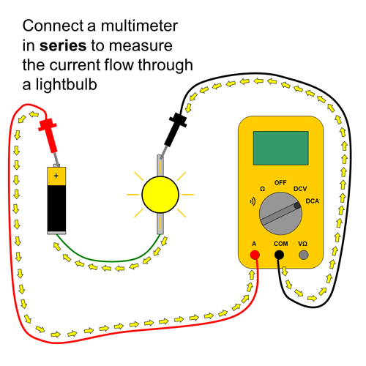
- Demonstrate how to use a multimeter. Assess understanding before giving students a multimeter.
  - Watch the Home Depot video
  - Read through How to Use a Multimeter
  - Possible Multimeter Safety Check - Google Form
- Measure circuit current
  - Connect a multimeter in series with the wire to measure the current being drawn by the lightbulb (this will help track the load in the circuit).
    - Video Example
    - How to Use a Multimeter
- Wire gauges current tests
  - American Wire Gauge Chart
  - Start with the thickest wire (18-gauge) and complete the circuit.
    - Remind students, when comparing metal gauges, the lower the number, the thicker the material. This means a 22 gauge is thicker than a 24 gauge.
  - Measure the current flowing through the circuit using the multimeter.
    - Run each circuit for at least 10 seconds to get an accurate reading
  - Observe how bright the lightbulb gets (brighter light typically means more current is flowing).
  - Record the Current: Note the current reading from the multimeter. You can also discuss how the wire feels by hand (i.e., whether it feels warm or not).
  - Repeat for Thinner Wires: Now, switch to thinner wires (e.g., 20-gauge, 22-gauge) and observe and record any changes in current and how the wire feels.
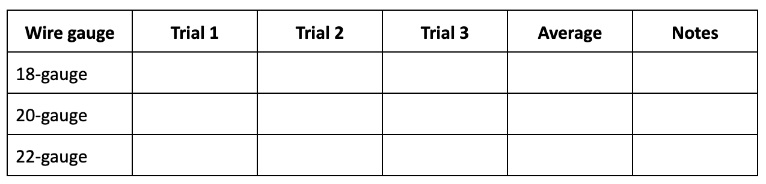
- Class discussion
  - Note - Thicker wires should be able to carry more current with less heat, while thinner wires may heat up faster and carry less current without reaching a dangerous temperature.
  - What happened when you used a thinner wire?
  - Did the current change?
  - Did the lightbulb get dimmer or brighter?
- Wire gauges temperature tests
  - Using a thermometer, students can measure the temperature rise of each wire during the experiment. Record all data in a data table.
    - Students will run each circuit for 60 seconds to see temp rise clearly.
  - Have students hold the thermometer to the wire at the start of the test and record temperature.
    - Demonstrate how to hold the thermometer and record temperature
    - If using a digital thermometer with a probe: Tape or clip the probe directly to the center of the wire (not near the ends or joints).
    - If using an IR thermometer: Aim it at the same section of the wire each time, about 2 inches from the middle.
  - Then have students record the temperature of the wire every 5 seconds for 60 seconds.
  - Repeat for Thinner Wires: Now, switch to thinner wires (e.g., 20-gauge, 22-gauge) and observe and record temperature changes.

What You Should See:
Wire Gauge | Expected Heating
18-gauge (thicker) | Little or no temp change—low resistance
20-gauge | Slight temp increase
22-gauge (thinner) | Highest temperature rise—more resistance = more heat
  - ⚡SAFETY:
    - Make sure connections are tight. Loose clips can skew results.
    - Never let the wire touch itself or short the battery.
    - Let the wire cool between tests.
    - Use the same start temp for each wire to compare fairly.
- Class discussion
  - Does the wire heat up more when using thinner wires?
  - Which wire handles the current without heating up too much?
  - Why do these tests matter?
- Graph data
  - Students graph the relationship between wire gauge and current capacity (ampacity). For each wire tested, plot current on the y-axis and wire gauge on the x-axis. Ask students to observe and share what they notice. Discuss how ampacity changes as the wire gets thinner.
  - Students graph the progression of the wire temperature for each wire gauge. For each wire tested, plot temperature on the y-axis and wire gauge on the x-axis. Ask students to observe and share what they notice. Discuss the temperature changes for each wire gauge.
- Problem Solving with Ohm’s Law
  - Ohm's Law is a simple rule that helps us understand how electricity flows through a circuit.
  - Introduce the equation I=V/R to predict circuit behavior.
    - Voltage (V): The electrical pressure that pushes the electricity through the circuit. It's like the water pressure in a hose.
    - Current (I): The flow of electricity. It's like the amount of water flowing through the hose.
    - Resistance (R): How difficult it is for the electricity to flow. It's like how narrow the hose is.
  - Provide example problems for students to solve based on their experimental data.
    - Sample problems below at the end of this lesson.

Closure/Review/Focus for Next Lesson
- Class discussion:
  - What are you curious about?
  - What did you learn about how wire thickness impacts current and temperature?
  - Why is it important for electrical engineers to choose the right wire for their projects?
  - How might your findings relate to electric vehicles and power systems?
- Switch Vehicle connection:
  - Take out and explore the different wires used in the Switch electric vehicle.
  - What is the power source? Are different wire gauges being used for different parts of the Switch circuits? What is the importance of each?
- Switch Relay connection
  - Take out and explore the wires used in the switch relay.
  - What is the power source? Are different wire gauges being used (not just different colors)? What is the importance of this?

Extensions

Digital Modeling

Use Tinkercad to simulate circuits with various wire gauges and analyze performance
  - Official Guide to TinkerCad Circuits
  - TinkerCad Circuit Tutorials

Guest Speaker or Virtual Tour

Invite an electrical engineer or take a virtual tour of a facility that designs wiring systems for vehicles or renewable energy projects.

Creative Project

Design a “Wire Gauge Guide” infographic explaining the properties and applications of different gauges.

*Additional Lesson Notes:
- Temperature data will have some inaccuracies. This lesson is looking at general temperature change between different wire gauges, but will not be exact.
- Graphs can be changed depending on how the class collects data. Graphs can also be completed as a class with discussion and questions.
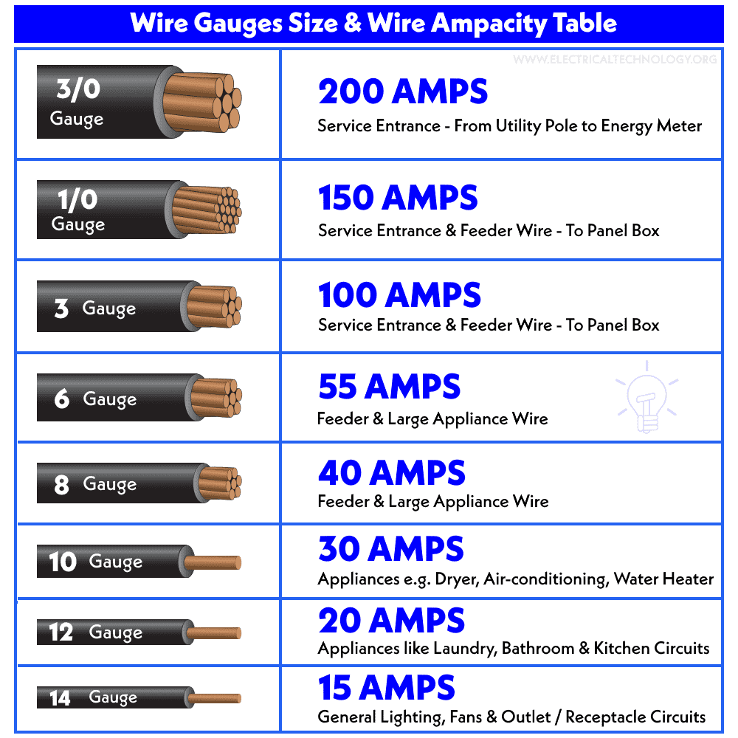
American Wire Gauge Chart - www.electricaltechnology.org/2022/04/american-wire-gauge-awg-chart-wire-size-ampacity-table.html/amp

Lesson 2 Vocabulary

Circuit: A complete path that electricity flows through.
→ Example: A flashlight has a circuit that sends electricity from the battery to the bulb and back.

Series Circuit: Electricity flows in one path only.
→ Example: Old holiday lights where one bulb going out makes them all go out.

Parallel Circuit: Electricity flows through more than one path.
→ Example: Lights in your house—one can go out, and the rest stay on.

Multimeter: A tool that measures voltage, current, and resistance.
→ Example: Use a multimeter to test a battery or check a circuit’s current.

Wire Gauge: The thickness of a wire (smaller number = thicker wire).
→ Example: 18-gauge wire is thicker than 22-gauge wire and carries more electricity safely.

Current (I): The flow of electricity through a wire or circuit.
→ Example: Like water flowing through a hose to spin a waterwheel.

Resistance (R): How much a material slows down electricity.
→ Example: Thin wires have more resistance—they can get hot faster.

Voltage (V): The "push" that moves electricity through a circuit.
→ Example: A 9V battery gives more push than a 1.5V battery.

Ampacity (Amps): The highest amount of current a wire can safely carry.
→ Example: If a wire's ampacity is 5 amps, sending 10 amps through it could melt it.

Insulation: The protective coating around wires that keeps electricity inside.
→ Example: The rubber on a phone charger keeps it safe to touch.

Ohm’s Law (I = V ÷ R): Shows how current, voltage, and resistance are connected.
→ Example: A 9V battery with 3 ohms of resistance = 3 amps of current.
Ohm’s Law Practice Problems

Problem 1: Simple Circuit
You set up a circuit with a 9-volt battery and a resistor of 3 ohms.
- What is the current flowing through the circuit?

Problem 2: Finding Resistance
In a circuit, a current of 2A flows when a 12-volt battery is connected.
- What is the resistance of the circuit?

------------------------------------------------------------------------------------------------------------------
Problem 1 Solution:
Solution:
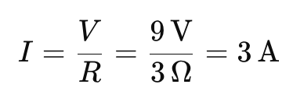
The current is 3A

Problem 2 Solution:
Solution:
Rearrange the formula
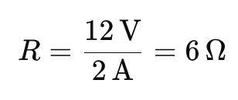
The resistance is 6Ω

