Lesson 4: Find the Fuse
Overview

California Content Standard(s) Addressed:
- NGSS ETS1.A: Defining and Delimiting Engineering Problems
- Crosscutting Concepts: Cause and Effect
- Science and Engineering Practices: Asking Questions, Developing and Using Models, Analyzing and Interpreting Data
- CCSS.MATH.CONTENT.8.F.A.1: Use functions to model relationships between quantities (e.g., current, resistance).
Essential Question(s):
How do engineers diagnose and fix circuit problems?
Objective:
Students will diagnose and troubleshoot circuits to understand the role of fuses and the impact of their failure.
Teacher Background Information + Common Misconceptions:
- Common Misconception: Students may think the fuse is “just another part” rather than a safety mechanism.
- Clarification Needed: A fuse is a sacrificial safety device. Its job is to melt or “blow” when current gets too high, breaking the circuit on purpose to prevent damage or fire.
- Review with students how to use a multimeter.
- Be sure to test fuses with a multimeter. Continuity mode is most common (look for a sound wave or diode icon). Touch probes to both ends of the fuse. If it beeps = fuse is good. If no beep or "OL" = fuse is blown
Student “I can” statements:
- I can identify the location of fuses in a circuit and explain their purpose.
- I can test a circuit to determine if a fuse is functioning correctly.
- I can analyze what happens when a fuse is removed or blown.
- I can troubleshoot and repair a simple circuit by replacing a fuse.
- I can describe how fuses protect electrical systems from damage.
Introduction/Engagement/Motivation
- Begin with a real-world scenario: Imagine you’re driving a vehicle, and suddenly the lights go out. What might have caused this, and how would you fix it?
- Show a blown fuse and an intact fuse side-by-side. Use a picture or pass around fuses if possible.
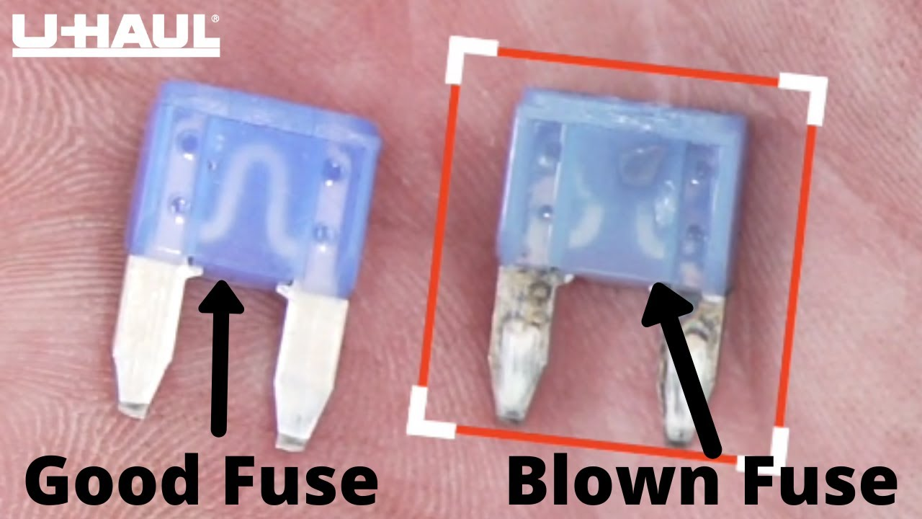
  - What do you notice about these fuses?
  - What do you think happened to the blown one?

- Explain the importance of fuses as safety devices in circuits.
  - Imagine your house's electrical wiring is like a water pipe system. Fuses are like little safety valves in those pipes. They protect the system from too much water (or electricity) flowing through.
  - How they work: Fuses contain a thin wire that melts when too much electricity passes through it. Think of it like a weak link designed to break before anything else does. When the wire melts, it breaks the circuit (path for electricity to flow), preventing damage to the wiring and appliances. (remember our series circuits?) This is like turning off the water supply before a pipe bursts. Without fuses, a faulty appliance or a short circuit could cause a surge of electricity, potentially leading to fires or damage to your electronics. Fuses prevent that by essentially "sacrificing" themselves to stop the flow of electricity.
    - Give students time to reword, discuss, and share questions with their team and through class discussion.

Materials
- Relay Lab Kit (used in the previous lesson)
- Multimeter
- Blown and intact fuses
- Spare fuses for replacement
- Circuit diagrams
- Chromebooks
Sequence of Learning Tasks:
- Introduction discussion about the role of fuses in the Switch Relay.
- Locating and testing fuses
  - Provide diagrams of the relay circuit from the previous lesson.
  - Guide students to identify where the fuses are located.
  - Demonstrate how to use a multimeter to test if a fuse is functioning.
    - Video: test fuse with multimeter
- Observing fuse failure
  - Have students remove a fuse from their circuit and observe the results (the circuit stops working).
  - Why did the circuit stop working?
  - What could happen if there were no fuse in this situation?
- Diagnosing and replacing fuses
  - Replace a fuse in each Relay Kit with an intentionally blown fuse.
  - Have students diagnose the issue, replace the fuse, and test the circuit again.
  - Emphasize safe handling practices.

Closure/Review/Focus for Next Lesson
- Class discussion
  - What real life applications could this be useful for?
  - Could a traditional car function without some fuses?
  - What approach did your group take to solving this problem?
  - How does understanding the circuits used help us identify the blown fuse?
  - How do blown fuses in cars affect the electrical system?
  - What steps would an engineer take to fix the problem?
  - What might happen to the Switch Vehicle if there was a blown fuse?
  - How might we find a blown fuse in the Switch Vehicle without checking every fuse?

Extensions
- Advanced Diagnosis
  - Introduce complex circuits with multiple fuses and challenge students to diagnose issues.
- Digital Circuit Simulation
  - Use a digital simulation to simulate fuse failures and test virtual solutions.
- Creative Project
  - Have students design a "Fuse Replacement Guide" for a fictional vehicle, including diagrams and step-by-step instructions.

*Teacher Resources:
- Good opportunity for students to go through parts of the engineering and design process.
  - Identify where the problem is centralized
  - Brainstorm solutions and where to start solving said problem
  - Design a plan and test
  - Share solution or how the students approached the problem (referenced in discussion portion)
- Be sure to clearly label which fuses are “blown” for student setups.
- Test fuses ahead of time (some blown fuses can look intact).
- Prepare extras—students may blow a fuse unintentionally.

